Specifications
  - ABT-IVC-0049 Entering and selecting part supplier number order confirmation
Doc Version <1.3>

Customer: | abatec
Project: | New Implementation
proALPHA version: | 9.3
proALPHA Installation(s): | DE
GUI language: | German
Author: | Marinko Ivic
Created on: | 27.04.2023
Last change on: | 03.04.2024
Contact Customer: | Ms. Zuparic

This document describes a modification or expansion of the standard software proALPHA and has been checked by the customer. The functional design in chapters 2 - 4 is hereby released for technical specification and costing in compliance with the requirements in section "Final Provisions":

......................................................
Date and Signature of Customer

Contents
1. [UPDATE THE TABLE] 3
1.1 [UPDATE THE TABLE] 3
1.2 [UPDATE THE TABLE] 3
2. [UPDATE THE TABLE] 4
3. [UPDATE THE TABLE] 4
3.1 [UPDATE THE TABLE] 4
3.1.1 [UPDATE THE TABLE] 6
3.2 [UPDATE THE TABLE] 7
3.2.1 [UPDATE THE TABLE] 7
3.2.2 [UPDATE THE TABLE] 7
3.3 [UPDATE THE TABLE] 8
4. [UPDATE THE TABLE] 9
4.1 [UPDATE THE TABLE] 9
5. [UPDATE THE TABLE] 10
5.1 [UPDATE THE TABLE] 10
5.2 [UPDATE THE TABLE] 11
5.3 [UPDATE THE TABLE] 11
6. [UPDATE THE TABLE] 12
6.1 [UPDATE THE TABLE] 12
6.1.1 [UPDATE THE TABLE] 12
6.1.2 [UPDATE THE TABLE] 12
6.1.3 [UPDATE THE TABLE] 12
7. [UPDATE THE TABLE] 13
8. [UPDATE THE TABLE] 14
8.1 [UPDATE THE TABLE] 14
8.2 [UPDATE THE TABLE] 14
9. [UPDATE THE TABLE] 15

Requirements

Summary and Objectives
The goal is to perform expansions in the following programs so that the user has more flexibility regarding the selection and check of the supplier part numbers and the underlying manufacturer part numbers.
- MRP suggestion: Expansion so that the respective manufacturer part can be selected by means of the part-suppliers number. (not applicable if implemented in the specs in Distidirect)
- Order confirmation: The part-suppliers numbers and manufacturer part numbers are to be displayed in the OC.

Requirements Glossary (Terminology)

Term | Explanation
ABT | Abatec
pA | proALPHA
Pu | Purchasing
OC | Order Confirmation
PU | Purchase Order
DP | MRP Suggestion
RLT | Replenishment times
Italic | pA Standard
Table 1Requirements Glossary

Basis pA Standard
Manufacturers are assigned to the parts. The manufacturer part numbers are updated for the respective manufacturer:
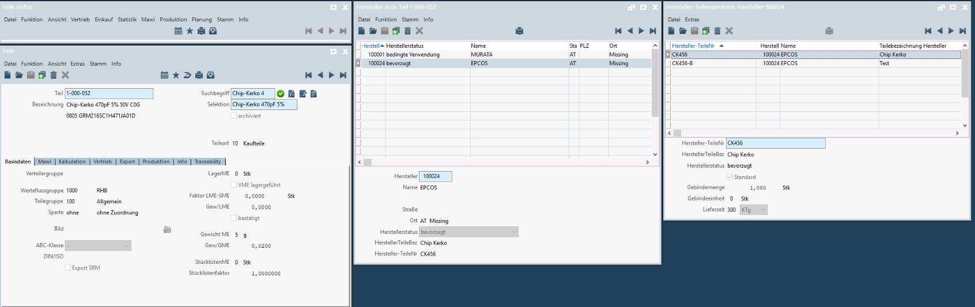
Mapping 1 Manufacturer part numbers: program: branche/stamm/proc/uswpma00.w, table: USM_PartManufacturer
Manufacturer: branche/stamm/proc/usppma00.w (USM_PartManufacturer)
The part-suppliers relationship defines the manufacturers that can be procured from a supplier:
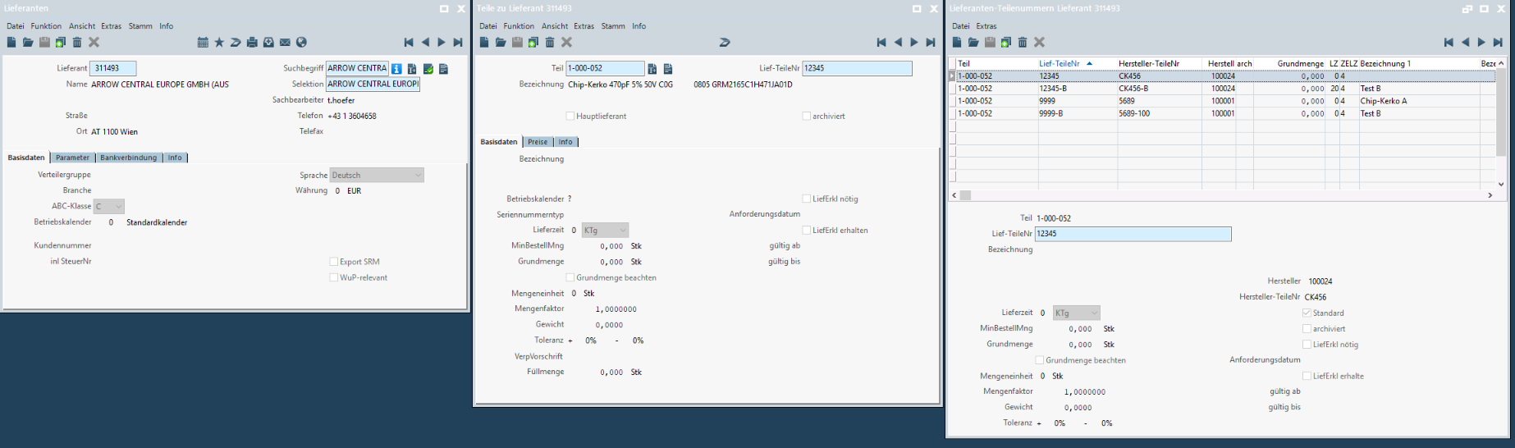
Mapping 2 Supplier part numbers: program: branche/stamm/proc/uswspo00.w, table: USM_SupplierPONumbers
Part supplier: eink/proc/e_wali03.w (E_ArtLief)
Part-suppliers-suppliers-part numbers: branche/stamm/proc/uspspo00.w (USM_SupplierPONumbers)

Extensions Order Confirmation

Adoption browser line order confirmation
Added the following fields to the adoption browser (e_bab_11.w):
- Supplier part number (already available, can only be edited)
- Manufacturer
- ManufacturerName
- Manufacturer Part No.
- 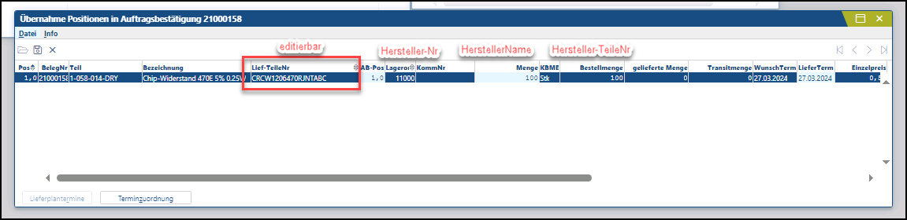
Mapping 8 Program: eink/proc/e_bab_11.w, table: TT_E_BelegPos
- The supplier part number is displayed from the purchase order line (case: CS0244994 - if it is a standard behavior, this has to be implemented in the course of this specification sheet). The manufacturer, manufacturer name and manufacturer part number are entered in the supplier part number (see: 2) and is to be displayed in this adoption browser. If the supplier part number is changed in the OC, no partial quantities are allowed. This means that 50 units of part number A and 50 units of part number B cannot be entered. This has to be done manually in the purchase order line.
- If the supplier part number is changed, the corresponding manufacturers' data are updated immediately. When the supplier part number is saved, it is also changed in the purchase order.
- The supplier part number is to be selected with CTRL+A. The browser has to be implemented analogously to the purchase order line:
- 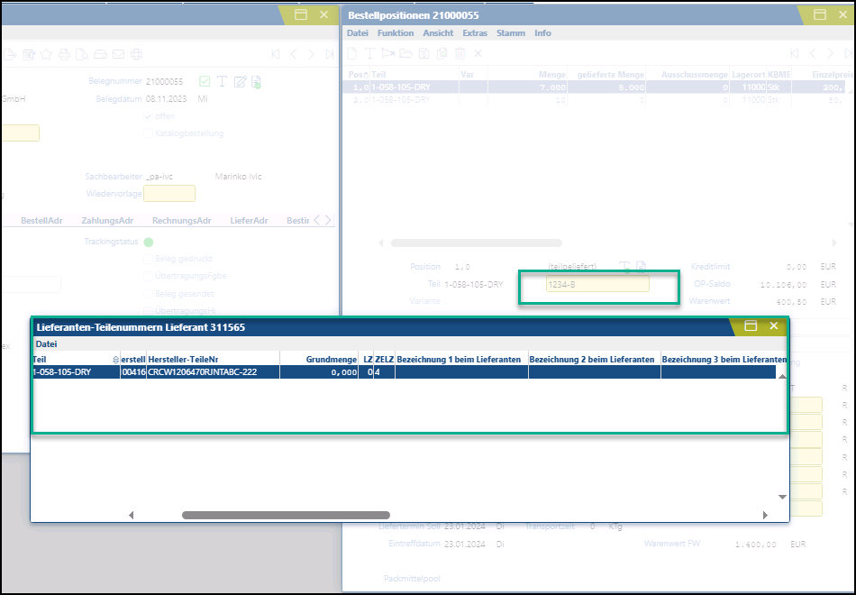

Lines for order confirmation
The following fields have been added to the "Lines Order Confirmation" browser:
- Supplier Part No.
- Manufacturer
- ManufacturerName
- Manufacturer Part No.
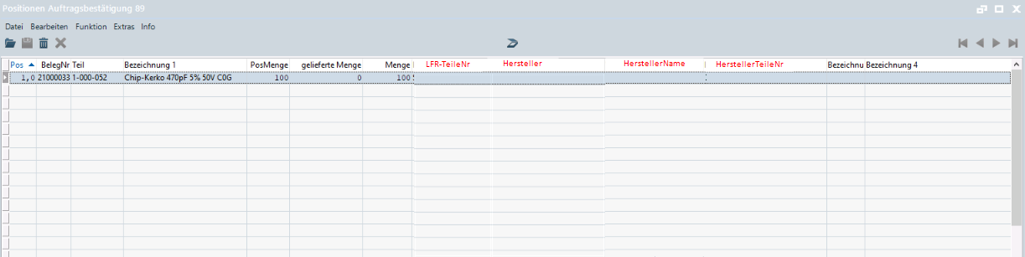
Mapping 9 Program: eink/proc/e_bab_04.w, table: E_AB_Pos

Differentiation
The customization refers to the tables, fields and programs mentioned.
These specifications do not automatically add functional extensions to the modules of the proALPHA environment, such as the DMS, Analyzer, reports, and forms. The proALPHA Help is not automatically extended either.
Changes to adjacent modules/programs must be described and defined in the specifications sheet.

Test cases
The specified test cases map the customization described here and are the basis for the acceptance of the software.

Part manufacturer numbers displayed in OC
Pt | Explanation | Expected result | Test data
 | Create a purchase order for a part with different supplier part numbers  The manufacturer and manufacturer number have been specified for the part supplier numbers | pA standard behavior  Example of test data:  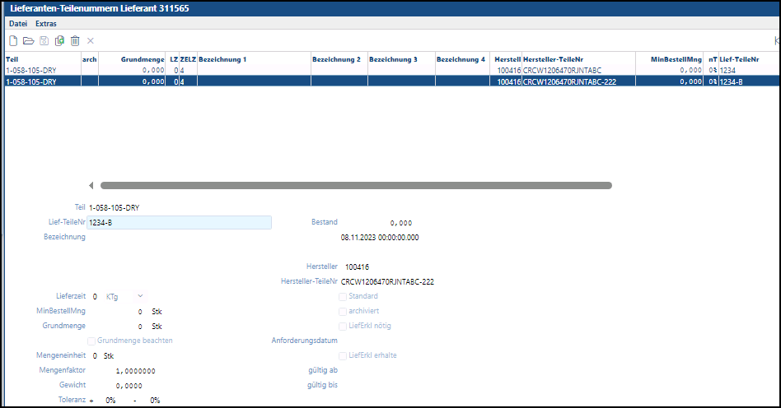  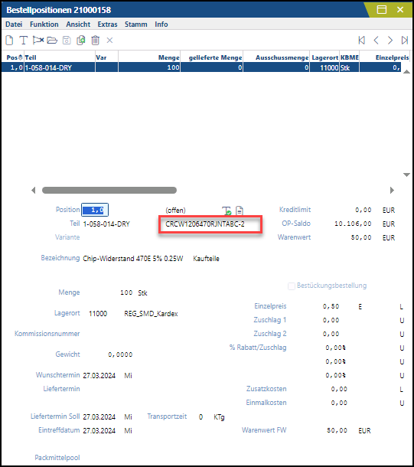
 | Test result (incl. screenshots)
 | Create order confirmation header  Adoption of lines of the purchase order created before | The following columns are additionally installed in the adoption browser and the Supplier Part Number column can be edited similar to the one in the purchase order line:    If the supplier part number is changed, the corresponding manufacturers' data are updated immediately. When the supplier part number is saved, it is also changed in the purchase order.  It is not possible to create different supplier part numbers for a purchase order line.
 | Test result (incl. screenshots)
 | Save (End Adoption - Complete) | The table with the line for OC is displayed.  The table contains new columns with the information. Only not editable displayed:  - Supplier Part No.  - Manufacturer  - ManufacturerName  - Manufacturer Part No.
 | Test result (incl. screenshots)

Requirements

Technical Requirements
The use of proALPHA functionalities outside the concurrent user model (connection of external systems, background processing) requires the licensing of so-called software services.
"Use of proALPHA functionalities" refers to any use or access to the proALPHA infrastructure, e.g.
- Writing to proALPHA data structures
- Calling proALPHA classes and other business logic
- Opening proALPHA Services
The implementation described in the specifications therefore requires the following software services:
- <Please list services here, otherwise delete section>
- ...

Organizational Requirements

Notes about the go-live

Technical Design

Part manufacturer numbers displayed in OC

- Define new temp-table fields —> Manufacturer No. , ManufacturerName , Manufacturer Part No. — > Temp-table TD_E_BelegPos

Adoption browser line order confirmation
- The first field already exists —> TT_E_BelegPos.BestellNr
- Enable this field —> e_bab_11.w —> local-apply-entry —> add new case
when 'PO#':U then
- CTRL+A —> PO# —> call d__aus01.w —> e_bali00.w
- Check when the PO Number field is changed then update other new fields.
- When save —> adopt to virtual field to E_BelegPos
Lines for order confirmation

- Create user exit for program e_bab_04.w
- New virtual fields for Supplier Part No. in table E_BelegPos and new variable for Manufacturer , ManufacturerName and Manufacturer Part No.

Final Provisions
These specifications form the basis for customer-specific extensions of the standard software proALPHA®.
The customer-specific extensions only cover the area defined in this specification sheet. Functionality beyond this scope is not provided.
Unless explicitly agreed otherwise, the customer-specific extensions are only created in German: no programs, program parts or data are translated into other languages. This also applies to the languages supported by ^{proALPHA®} in the standard version.
The customer-specific extensions are thoroughly tested before they are delivered. However, for technical reasons, it is not possible to perform the test under the same conditions and with the same data as the customer will use. It is therefore recommended to carefully check the functions in the real system environment after their delivery.
The Customer is aware that the transfer of the functions defined in this specification sheet to new versions of proALPHA® may require deviations in the display details or handling. This specification sheet also remains valid in this case, provided that there is a maintenance agreement for the customer-specific extensions defined in this specification sheet and no changes to the functionality have to be agreed on.
This specification sheet documents the customer-specific extensions. No other documentation beyond the specifications contained in this specification sheet is to be provided. Questions about customer-specific extensions are received and forwarded by the hotline.
By signing on page 1, you confirm:
that the specification sheet is accepted in this version and becomes part of the contract,
that this specification sheet defines the functional scope of the software to be created and that there are no side agreements regarding the functionality.

Annex

Table of Figures
[UPDATE THE TABLE] 5
[UPDATE THE TABLE] 5
[UPDATE THE TABLE] 7
[UPDATE THE TABLE] 8
[UPDATE THE TABLE] 8

Table of tables
[UPDATE THE TABLE] 4

Change History
Doc. -  Version | Date | Specialist | Initiator | Chapter | Explanation
<1.0> | 05.05.2023 | Marinko Ivic | Ms. Zuparic | All | Initial new entry
<1.1> | 07.02.2024 | Marinko Ivic | Ms. Zuparic | All | Revision after meeting with Ms. Zuparic
<1.2> | 27.03.2024 | Marinko Ivic | Mr. Tewes | 3.1 | Discontinued or moved to specifications sheet DistiDirect & Test cases
<1.3> | 03.04.2024 | Marinko Ivic | Mr. Ivic | 3.2.1 | Detailing

